**JDBC Coonection**

1. **Download Java MySQL Connector *‘mysql-connector-java-5.1.34-bin.jar’* and keep it on the desktop**
2. **Create a Java project in Eclipse IDE**

* Open Eclipse IDE. Create a new Java Project and name it as “mydbproj”.

1. **Configure JDBC driver in Eclipse IDE**

* You need to add the downloaded Java MySQL Connector JAR in client **project’s classpath**. To do this,**right click on your Java Project (mydbproj) -> Properties -> Buildpath -> Libraries -> Add External JAR and select “mysql-connector-java-5.1.34-bin.jar” JAR file**.

1. **Set up a simple Consumer program**

**import** java.util.Arrays;

**import** java.util.Properties;

**import** org.apache.kafka.clients.consumer.ConsumerRecord;

**import** org.apache.kafka.clients.consumer.ConsumerRecords;

**import** org.apache.kafka.clients.consumer.KafkaConsumer;

**public** **class** Consumer {

**public** **static** **void** main(String[] args) {

Properties props = **new** Properties();

props.put("bootstrap.servers", "localhost:9092");

props.put("group.id", "group-1");

props.put("enable.auto.commit", "true");

props.put("auto.commit.interval.ms", "100");

props.put("auto.offset.reset", "earliest");

props.put("auto.commit.interval.ms", "1000");

props.put("session.timeout.ms", "30000");

props.put("key.deserializer", "org.apache.kafka.common.serialization.StringDeserializer");

props.put("value.deserializer", "org.apache.kafka.common.serialization.StringDeserializer");

KafkaConsumer<String, String> kafkaConsumer = **new** KafkaConsumer<>(props);

kafkaConsumer.subscribe(Arrays.*asList*("faculty"));

**while** (**true**) {

ConsumerRecords<String, String> records = kafkaConsumer.poll(10);

**for** (ConsumerRecord<String, String> record : records) {

System.***out***.println("Partition: " + record.partition() + " Offset: " + record.offset()

+ " Value: " + record.value() + " ThreadID: " + Thread.*currentThread*().getId());

}

}

}

}

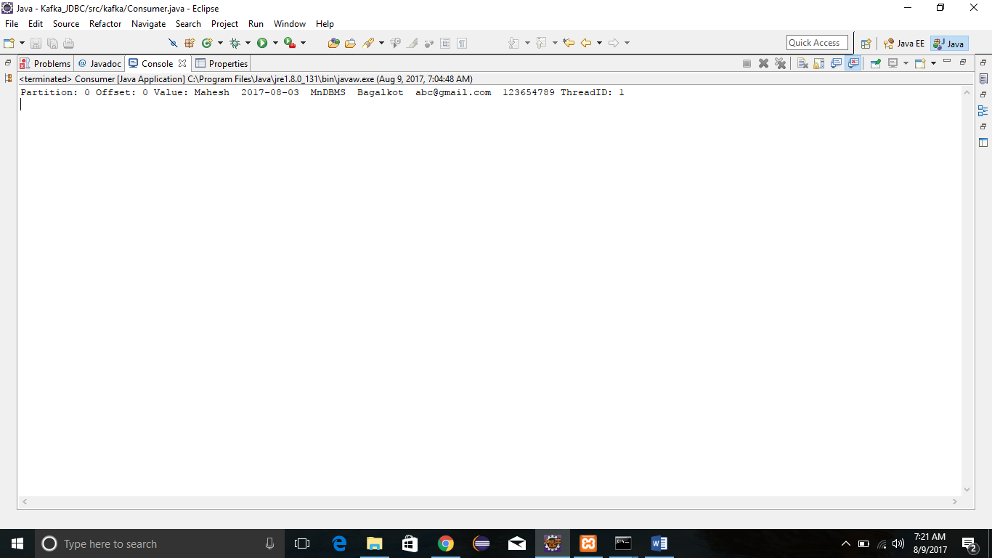

1. **Run the program ->click on Java file -> RunAs-> Java Application. You will get the following output.**

Successfully connected to MySQL server...